SCHOOL OF COMPUTER SCIENCE AND ARTIFICIAL INTELLIGENCE |  |  |  |  | DEPARTMENT OF COMPUTER SCIENCE ENGINEERING
ProgramName:B. Tech |  |  |  | SET-A |  |  | AcademicYear:2025-2026
Roll No.
Instructor(s)Name |  |  |  | - Dr. Venkataramana  - Dr. Ch. Sridhar  - Mr. Kundan
CourseCode |  |  | 24CS002PC215 | CourseTitle |  | AI Assisted Coding
Year/Sem |  |  | II/I | Regulation |  | R24
Date and Day  of Assignment |  |  | 22.08.2025 | Time(s) |  | 01.00PM To 03.00PM
Duration |  |  | 2 Hours | Applicableto  Batches |  | 24BTCAIAIB09, 24BTCAIAIB10
Lab Test :1(Present test number)/4(Total number of tests)
 | Q.No. | Question |  |  |  |  |  | ExpectedTime  to complete
 | 1 | Task Description#1  - Write Python function with the help of GitHub Copilot and VS Code to classify the people based on Age Group. And explain the code with required comments  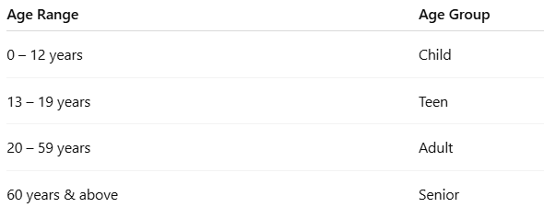  Prompt:Give me code of python function to classfy the people age based on group.and give me the required comments with help of code.  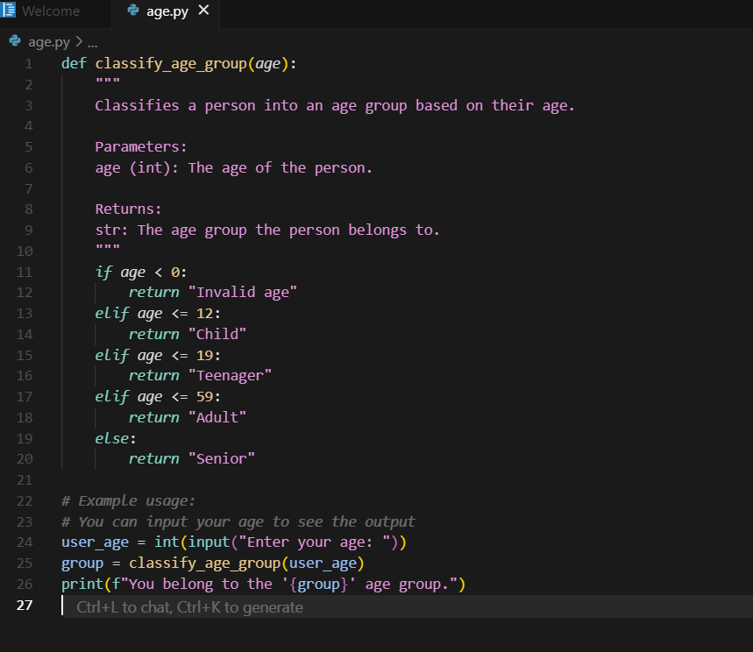  Expected Output#4  - Age_Classifies function  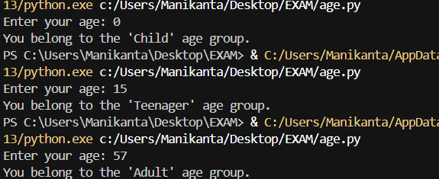  Task Description#2  - Write Python program in cursor AI for student class with attributes like Name, Roll no, Marks and also construct a method i.e., display_details to display name, rollno and marks  Prompt:Give me a python programming code using the cursor ai for student with the help of attributes like name,roll no,and marks.  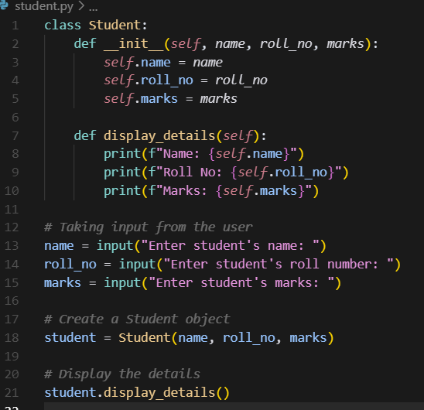  Expected Output#5  - Student Class and Display Details  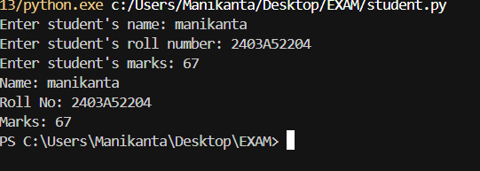  Note: Report should be submitted a word document for all tasks in a single document with prompts, comments & code explanation, and output screenshots  Evaluation Criteria: |  |  |  |  |  | 22.08.2025 03.00PM
  Criteria | Max Marks
  Factorial Function (Task#1) | 5
  Sorting Function (Task#2) | 5
  Viva | 5
  Total | 15 Marks

